THE 20th DORSET RAPIDPLAY CHESS CHAMPIONSHIPS AT RINGWOOD
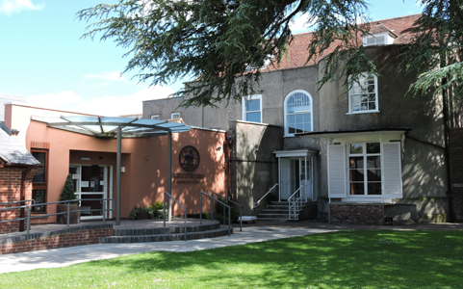
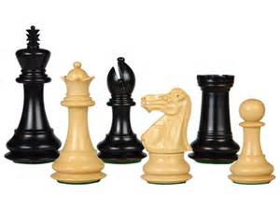
(6 Rounds : 30 minutes each for the complete game)
9.45am to 6.00pm, Sunday 22 March 2015
Greyfriars Community Centre, 44 Christchurch Rd, Ringwood BH24 1DW
* Guaranteed Minimum of 13 prizes!
* FREE hot and cold buffet lunch!
* Hot and cold drinks throughout
1st Prize - £60 (+ bonus if score achieved is 6 out of 6!)
2nd Prize - £40
3rd Prize - £20

The Dorset Rapidplay Championship Cup will be awarded to the highest placed player who has, in 2014/15, played in either the local Dorset or Bournemouth & District Chess Leagues or was born in Dorset.

There will be 5 grading prizes £20 each to be determined by the controller.
There will be additional junior prizes, including £20 to best placed junior
Best Score for 1st Round Loser Book Prize (If tie, awarded to lowest graded)
Best Score for Last 3 Rounds Book Prize (If tie, awarded to lowest graded)
Best Veteran (Over 60) Book Prize and Trophy
Best Team Score of 4 Players £20 (Average team grade must be 145 or less)
Booby Prize for worst performance relative to grade!

Entry Fee: £10.00 (£8.00 for veterans whose date of birth is prior to 23.03.55)
(£6.00 for juniors whose date of birth is after 22.03.97)

Late Fee: £3.00 for all entries accepted on the day of the event.

Numbers are limited, so entries will be strictly on a first come, first served basis.
We have chosen a central venue to try and attract players from a wide area,
including Hampshire & Wiltshire. This is a Dorset County Chess Association event
_____________________________________________________________________
ENTRY FORM Please forward to: Michael Jay, 37 Davids Lane Ringwood Hampshire
BH24 2AW (Tel: 01425 461756)
(michael.jay2@btinternet.com)
Name .............................................. Grade .............. Club ................................................
DOB (if veteran or junior) ...............................................

Address .......................................... Entry Fee £................ Please make cheques payable to:-
.......................................... Ringwood Chess Club
.......................................... Late fee £................
.......................................... Donation £................ (To help defray expenses thank you)
Tel .......................................... TOTAL £................
Email ……………………………………………………………………………..(for confirmation and advising re next year)
If you prefer to enter and also pay your entry fee electronically, please complete the details above and email to me and I will advise bank details
Regular entries updates on http://dorsetrapidplay.weebly.com

